Workshop Gunadarma

NAMA : Naufal Andresya Kholish

NPM : 51421122

KELAS : 3IA26

MATERI : HTML

Video Pertama

Listing program

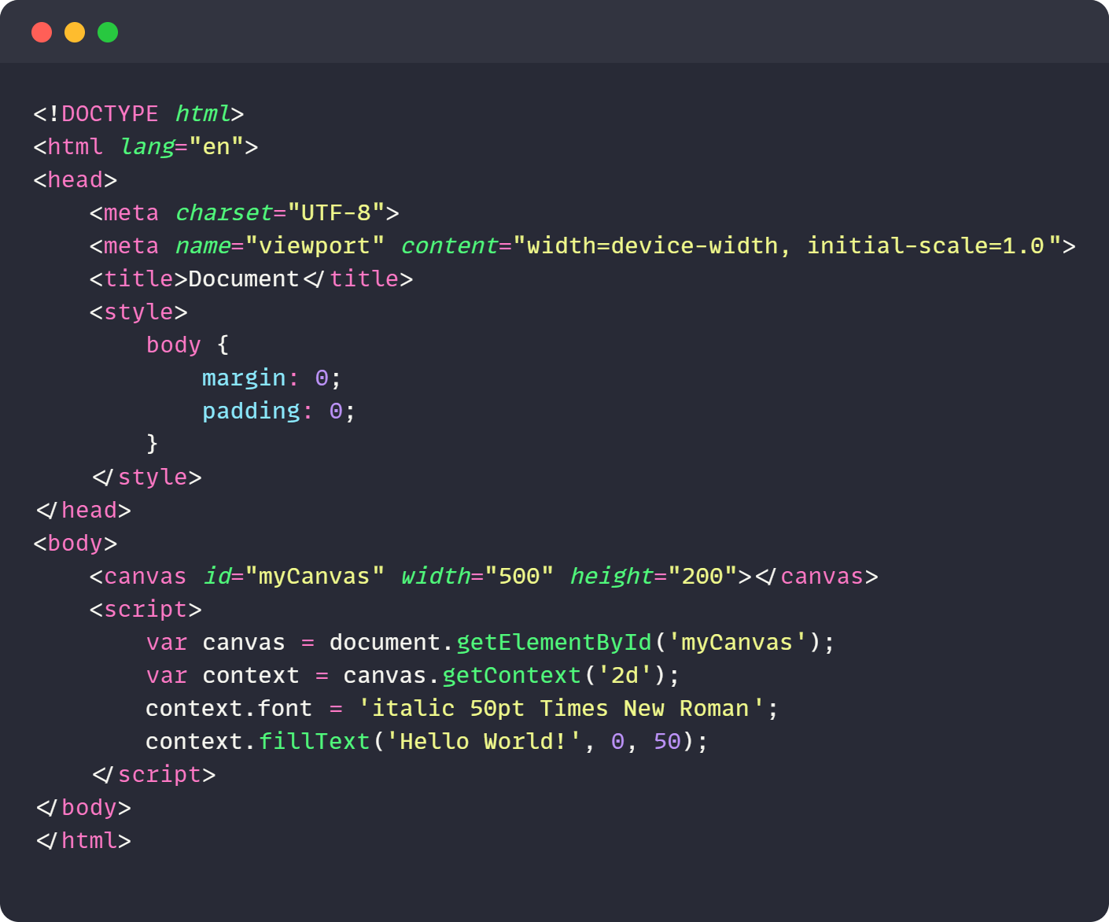

Output Program

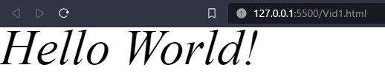

Video Kedua

Listing program

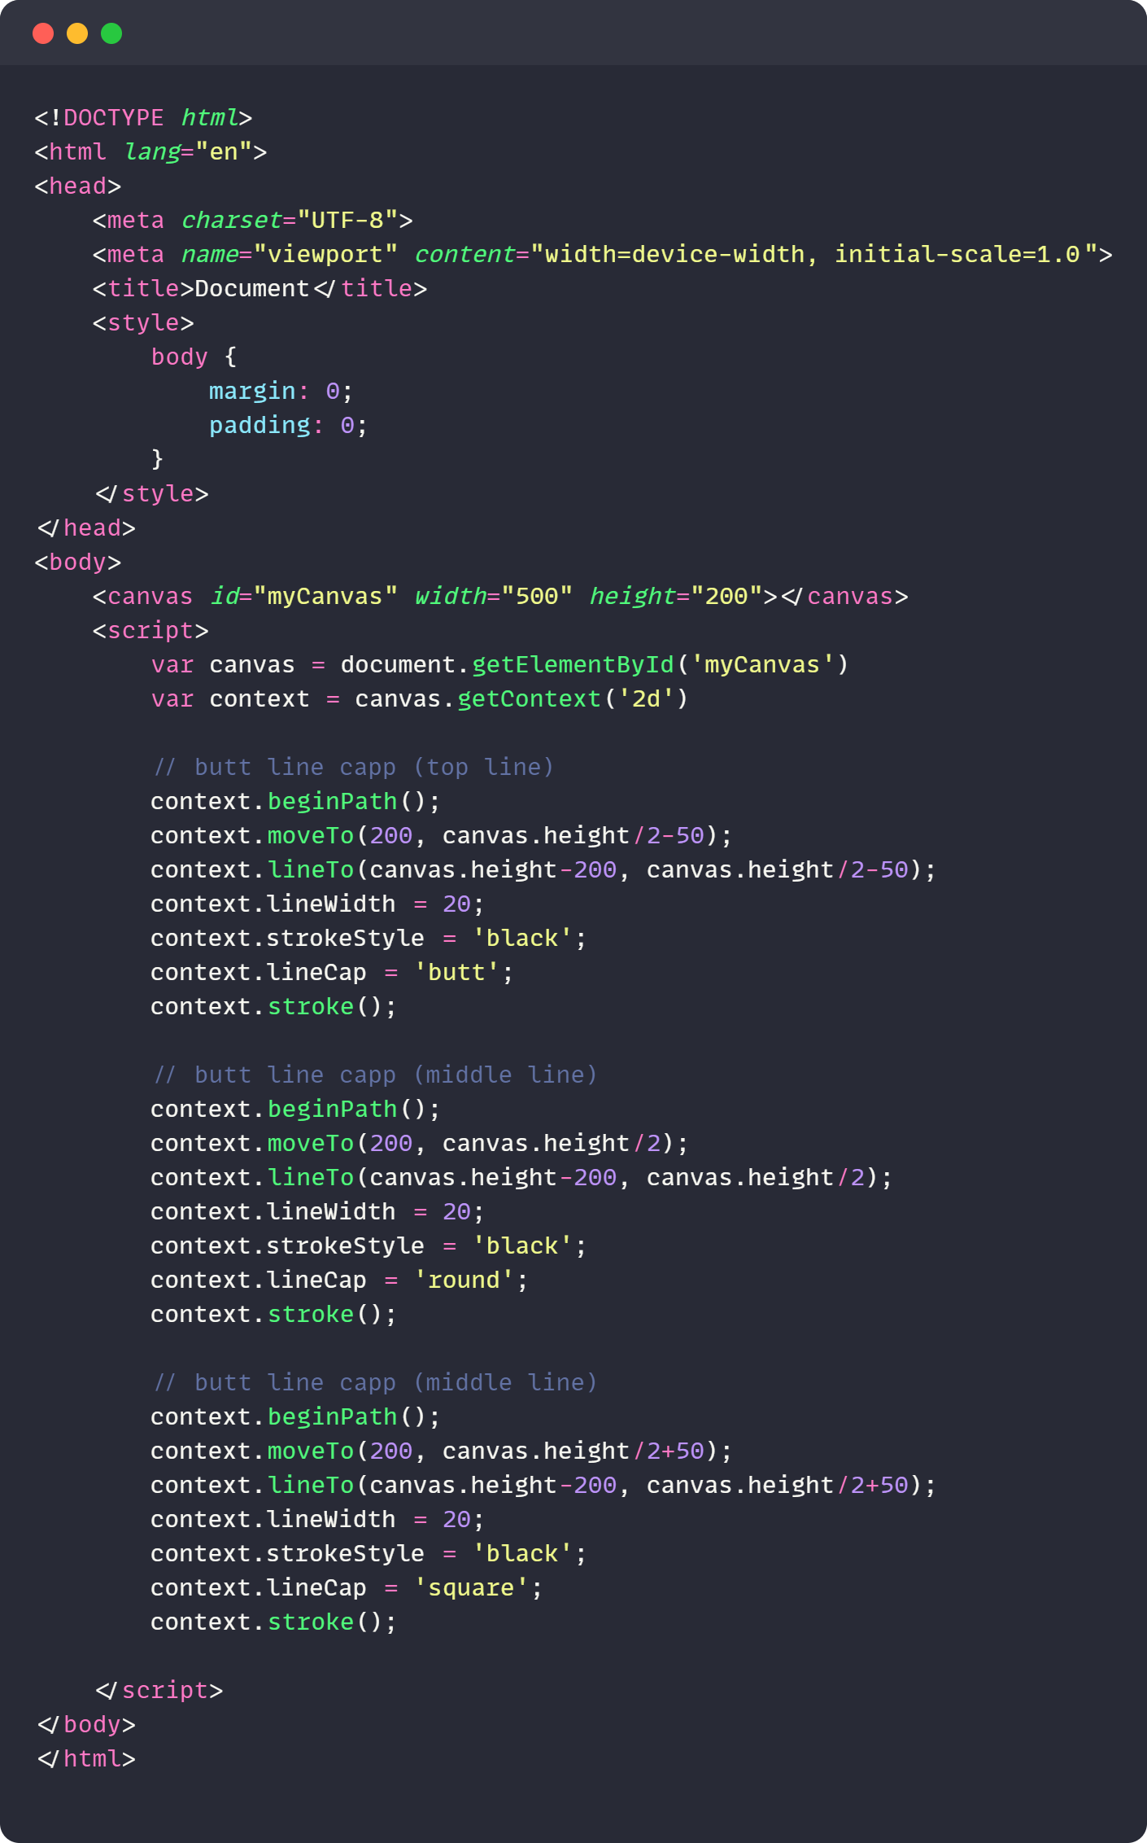

Output Program

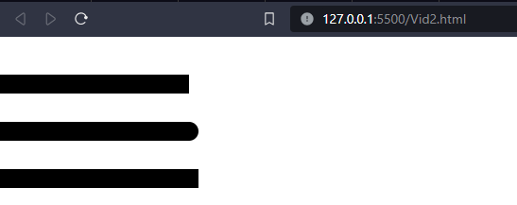

Video Ketiga

Listing program

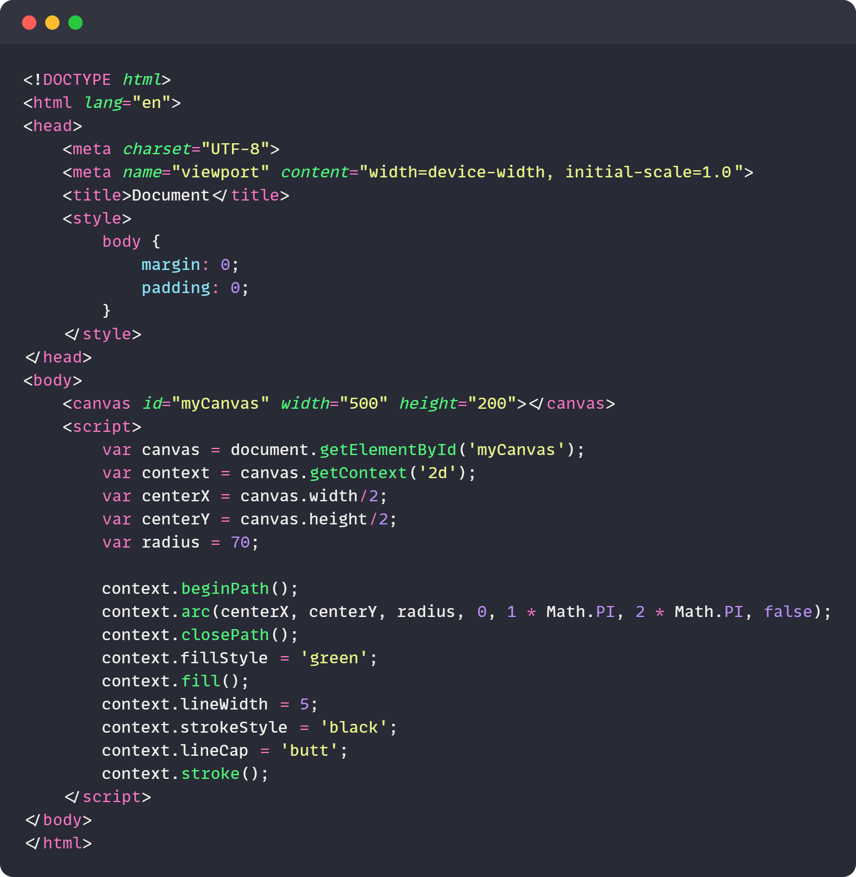

Output Program

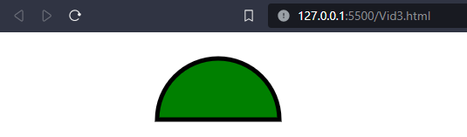

Video Keempat

Listing program

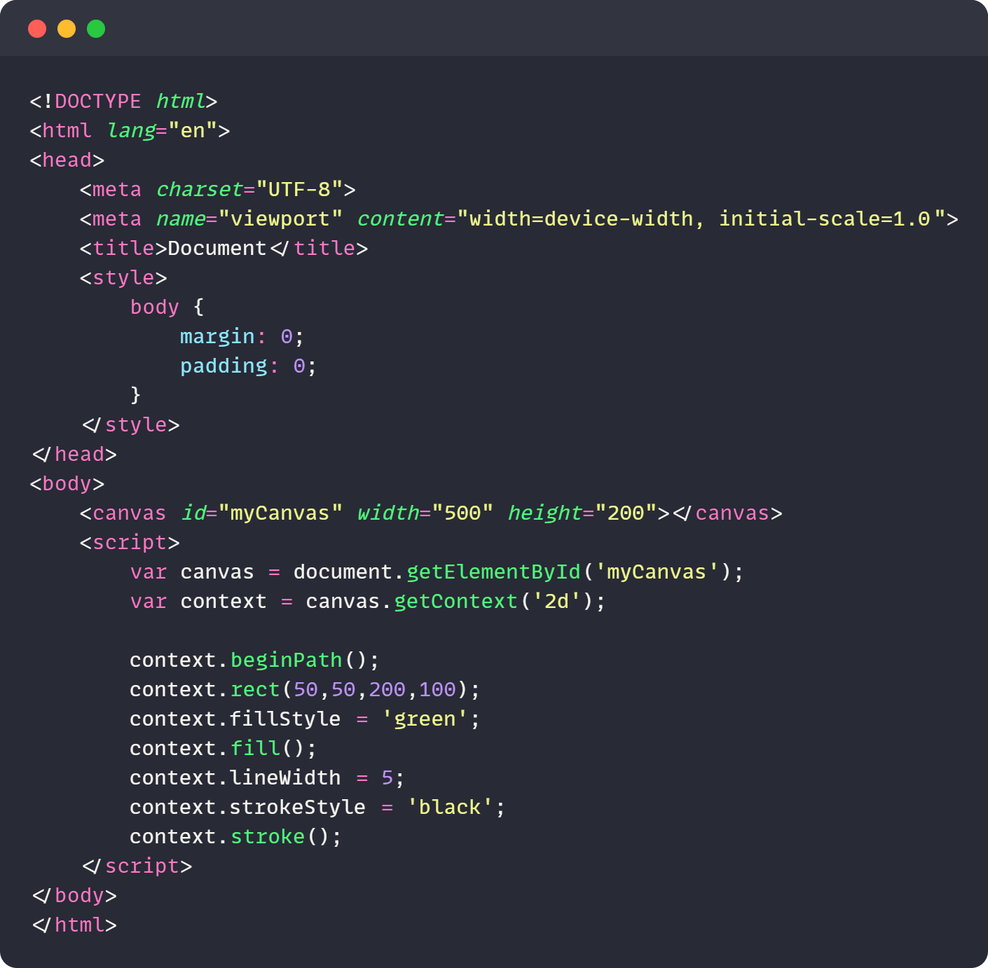

Output Program

